EXPERIMENT 7: ***Biasing Perception via Pre-Stimulus Short-Train TMS, Romei et al., 2010***

**Introduction**

* Once proven the correlation between prestimulus alpha band and certain mental states, the aim of this new experiment was to ***prove causality*** by the exploitation of *rTMS bursts*, calibrated to that the frequency of the stimulation would coincide with the natural frequency of alpha bands in the targeted brain area, to ***entrain oscillations at the frequency of stimulation*** and eventually show that ***subjects perception could be biased in desired directions*** thanks to this train
  + indeed, provided that the entrainment can be achieved, this synchronization in the alpha bands should enhance their power, eventually leading to a drop in the subject’s perception
* **Question**: Can we transiently induce oscillatory brain activity patterns to generate mental states and modulate functions? Can perception be biased in desired directions with pre-stimulus TMS at alpha (but no other frequencies)?

**Objective**

* Look for a link between frequency TMS and outcome.

**Protocol/Techniques**

* Use of rTMS and EEG to record alpha activity

**Method**

* The experiment was tested by undergoing participants ***five subsequent (five pulses), rhythmic TMS burst*** and asking them whether they perceived a phosphene or not; they had to press a button every time they perceived the stimulus
* *rTMS* exposition was done for several minutes in order to cover different tests involving different parameters, such as
* *two* *stimulation sites* (parietal vs occipital: these two areas are important for spatial attention)
* *two* *stimulation sides* (left vs right hemisphere)
* *three stimulation frequencies* (5Hz theta, 10Hz alpha, 20Hz beta)
* *two target locations* (ipsilateral vs contralateral)

the total number of runs was, then $2×2×3×2=24$, each one involving *7*-time frames for *EEG recording*, then the experiment was repeated with a sham *TMS* in order to get data normalized over the control condition

* From the measure a fake stimulation is subtracted to remove effects caused by the click on the coil

**Results**

**1) Immediate effects**

* results shown that, independently from site and side, no matter what we stimulate the stimulation will lead to the same outcome, showing that the ***entrainment had been successfully achieved*** and that its consequences were ***particularly noticeable for frequencies around 10Hz*** respectively to those around *5* or *20Hz*, also
* as one would expect, with targets located in the contralateral area subject’s detection was reduced, while with targets located in the ipsilateral area subject’s detection was enhanced, meaning that ***entrainment of waves in one hemisphere entailed a desynchronization in the other one***
* What we are observing is that ***the application of TMS***, ***specifically in the alpha band*** compared to the other frequency bands, is having an ***effect that is:***
  + ***frequency specific*** because this effect is specific for this frequency and not for the other frequencies
  + ***spatial specific*** because the effect depends on the stimulus that is presented ipsilateral or contralateral.
* So when the stimulus was presented ***ipsilateral to the TMS*** (same side of the application of TMS), there was a sort of releasing performance getting better performance, while ***if it was contralateral*** it was getting ***worse***.
* This is confirming the fact that ***the alpha power has an inhibitory effect contralateral, while is having an improvement in the case of ipsilateral TMS***.

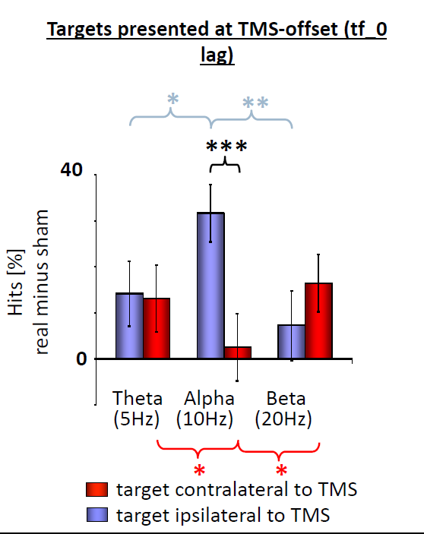

**2) Effect timing**

* the effect lasted no more than 3.5 seconds, indeed no evident change can be seen in the last time frames

**Conclusion**

* this study proved that ***alpha-activity is not merely an epiphenomenon*** *as it can shape perception*, indeed posterior alpha-oscillations have an active role in perceptually relevant tuning of visual areas for sensory selection, and also that it ***is possible to bias*** (both to ***inhibit and enhance, depending on the hemisphere) an individual’s visual perception by means of rhythmic transcranial stimulation***

**TO REMEMBER:**

* With rTMS we can have an entrainment in one hemisphere and desynchronization in the other
* Alpha activity shapes perception so we can individuate a causal role
* Inhibit alpha activity in the stimulated area as a result of the synchronization obtained with rTMS reducing visual performance contralateral to TMS and enhancing the performance ipsilateral to TMS.
* We can select information in the sensory by modulating alpha activity